Report & Accounts for the 12 month period ended
31st March 2022

THE 5TH WOODBRIDGE (SEA SCOUT) GROUP

GROUP EXECUTIVE COMMITTEE

Group Scout Leader Mr B Hayter
Group Executive Chairman Mr M Bell
Group Secretary Dr N Notcutt
Group Treasurer Dr J Douse
Scout Leader Mrs N Tooke
Cub Scout Leader and Deputy GSL Mrs M Ulph
Beaver Leader Ms S. Ngassa
Explorer Scout Leader Ms. J. Stone
Membership Secretary Dr N Notcutt
Beaver Parent Representative Mr H Banhm
Cub Parent Representative Mr M Davies
Quartermaster Mr M Davies
Bosun Mr D Russell
Scout Parent Representative Mr B Whittle
Fundraising Coordinator Mrs J Perry

TRUSTEES: Elected
Group Scout leader Mr B Hayter
Group Executive Chairman Mr M Bell
Group Secretary Dr N Notcutt
Group Treasurer Dr Jonathan Douse
Scout Leader Mrs N. Tooke
Cub Scout Leader Mrs. M. Ulph
Beaver Leader Ms S Ngassa

BANKERS: BARCLAYS BANK PLC, Woodbridge Business Centre, Suffolk Coastal Group
4 Church Street, Woodbridge, Suffolk, IP12 1DJ

CUSTODIAN TRUSTEES: None

OTHER ADVISERS: None

Group Registration Number with The Scout Association: 40674

Charity Registration Number: 268625

Royal Navy Registration Number: 93

Contact Name and Address: Group Executive Chairman, 5th Woodbridge ( Sea Scout) Group
5-7 Tide Mill Way, Woodbridge, Suffolk, IP12 1BY.

TRUSTEES ANNUAL REPORT

For the 12month period ended 31st March 2022

activities and achievements in the year

GROUP SCOUT LEADERS REPORT– Barrie Hayter Group Scout Leader
5th Woodbridge Sea Scouts have grown both in capacity and capability this year. The group opened a new Scouts section in January with 7 new leaders. With 16 new youth members we plan to grow this to 28 over the coming year. All other sections are at capacity.

Coming out of lockdowns has been difficult but the section teams have been amazing and are working hard to recover lost time and teach our young people #skillsforlife. Two of our leadership team were nominated for Merit Awards and were awarded them in 2022.

The group worked extremely hard on grant applications and making sure we maximised the COVID grants that were available. We purchased new outdoor shelters, tables and benches and 4 new patrol tents all with grants from local organisations. The group also purchased a brand new RIB to use as our safety boat and a floating dock to keep it out of the water. We were also donated a trailer with 10 kayaks and 4 open canoes from a local water sports centre. The group now has all of the water capability it requires and will concentrate on building fund raising for the next few years.

The new building plans are progressing and we are looking to use shipping containers modified locally by the owner of Eversons boat yard. This will reduce the build costs and amount of time the hut is not available.

The group is continuing to work closely with Woodbridge Town Council, East Suffolk District council, County Council and many other local groups.

In June 2022 we celebrated our 50th Year and had all youth and adult members on the water at the same time. The day was a great success and shows just how much support we have.

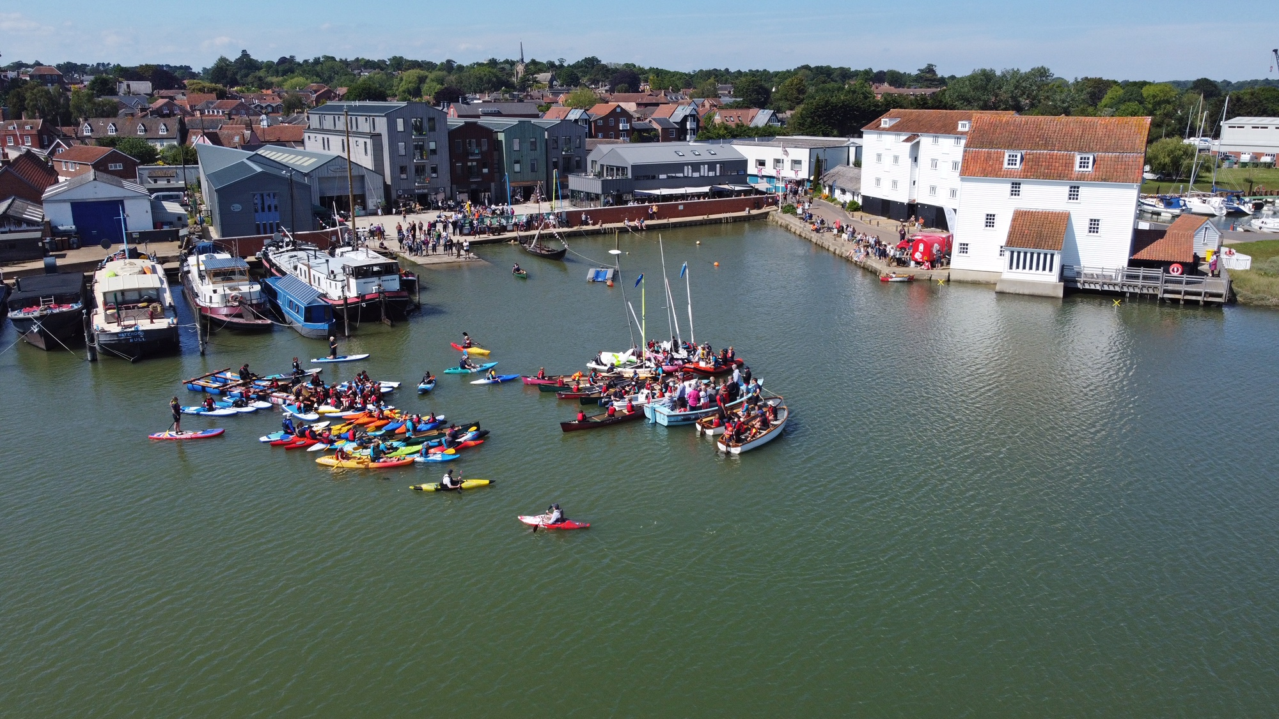

The waiting list is sitting at around 150 youth members across ages 0-17. The below graph and table show the age distribution and how long they have been on the waiting list. We have had 112 join the waiting list in the last 12 months showing a real demand for extra sections. The group plans to open a Cubs section in September 2022 and a new Squirrels and Beavers Section in 2023. Once all sections are open our youth membership will be over 200.

Length On waiting list | Count Of all | Count of kids old enough to join
0 to 0.5 | 60 | 44
0.5 to 1 | 52 | 42
1 to 1.5 | 28 | 23
1.5 to 2 | 7 | 3
2 to 3 | 3 | 2
3+ | 3 | 2

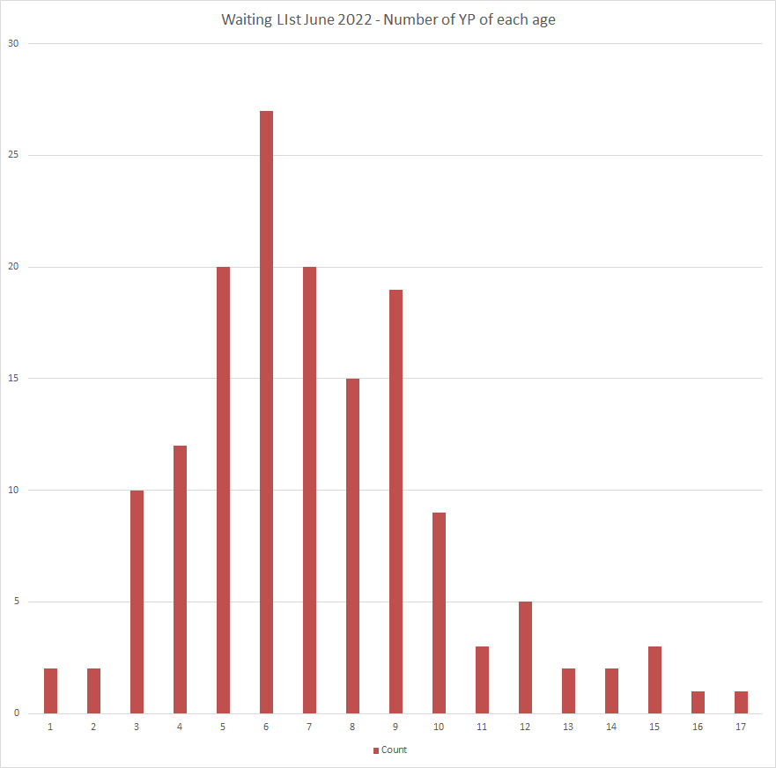

The group has a full and active Exec Team who also work incredibly hard to ensure the funds, equipment and capability are available to support the section leaders in delivering an awesome quality program.

I would like to thank everyone involved with the group as without all of the support we would not be in such a strong position.

BEAVER SCOUT REPORT – Pippa Calver Beaver Leader
We've had another successful year with our Beavers. It was fantastic to have some normality after doing the zoom sessions we ran throughout lockdown.

This year the Beavers have enjoyed activities like orienteering, jubilee crafts, making boats & sailing them on our local boat pond! They have also enjoyed the water sessions were we went to in a local reservoir. All these activities contributed to them gaining badges such as "Creativity" "Explore" and ."Sports"

We have a fun filled programme going forward into the Autumn term which we are all looking forward to.

CUB SCOUT REPORT – Maggie Ulph, Cub Scout Leader
We have had a full year of activities indoors and outdoors and very notably free of covid restrictions. What a difference a year on this has been to the two years before. We have had a very successful cub camp post covid 5 days and 4 nights away at Hallowtree and opportunities for plenty of water activities which is reflected in the badge awards:
X 18 Paddle sport
X2 Sailing
X31 time on the water
All in all, we have awarded 256 Badges including x1 Chief Scout Silver.

Cubs are the middle section so we see first hand the movements through the sections as Beavers move up to us when 8 and Cubs up to Scouts when about 10 and a half. This year we have had 13 investitures into Cubs. We currently have 28 Cubs, 3 young leaders and 8 leaders.
The exciting news for us is that a second 5WSS cub section will be starting on September 14th on a Wednesday evening and they will be working in tandem with the Tuesday night cubs programme.
These are children that have been on our waiting list for a long time. They will have their own leaders from volunteers (mostly from the parents of children who will form our new cub section) and we very much look forward to getting the two sections together at some points during the terms so that they can get to know each other. I would like to say a big thank you to the Cub parents for being so very supportive of what we do. We couldn’t do half as much of what we do without your active support, so thank you all.

SCOUT REPORT (Friday section) – Nicola Day, Scout Leader
After surviving the restrictions of COVID-19, we are well and truly back in the game!

Friday troop numbers have remained steady at 32 Scouts and we currently have 3 fantastic Young Leaders. We continue to have a strong leadership team who have ensured that we are able to offer our varied, high-quality programme. We have also welcomed two Ukrainian refugees to our troop, with help from one of our parents who is in interpreter.

We have continued to run Junior Officer training and selection sessions and are very pleased with our current group of JO’s. Throughout the year we have awarded a few more Chief Scout Gold Awards, the highest award available in the Scout Section, with a few more on the horizon. We have also awarded what we believe to be the first complete Youth Shaped Award in the country (well done Nina!), as well as hundreds of other badges!

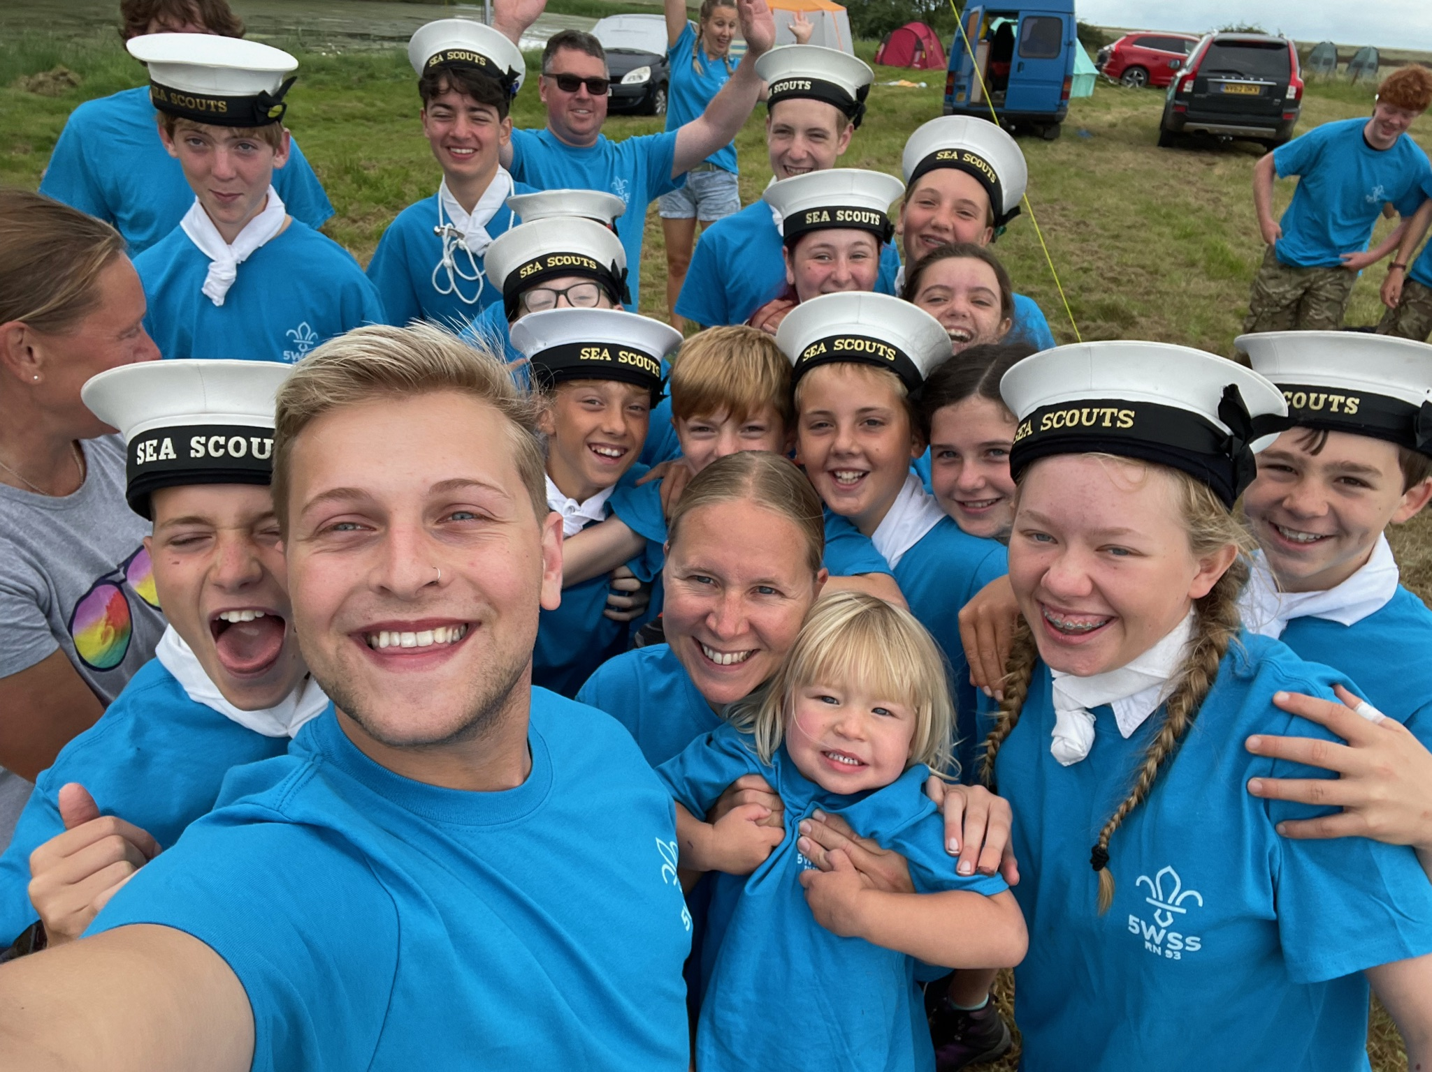
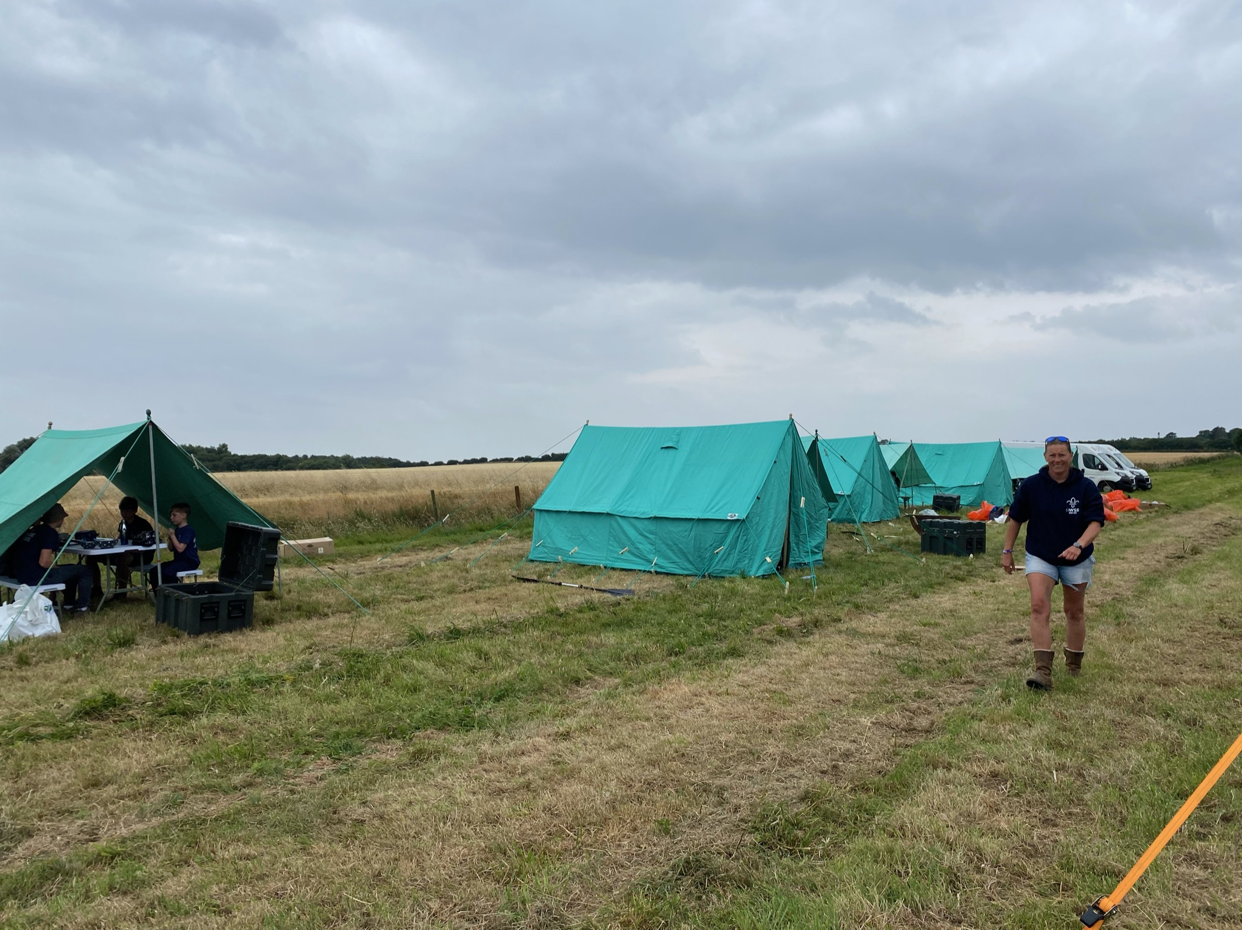
Summer ’21 was the return of a real Summer camp! We spent a week near Boyton going back to basics; digging long drop toilets, hiking, preparing pigeons and rabbits for dinner, boating (of course) and having many an adventure. It was brilliant to be back to something like normal. Whilst some Scouts struggled being away from home after lockdown, the vast majority had a fantastic week. We also used our brand-new ridge tents, which we love very much.

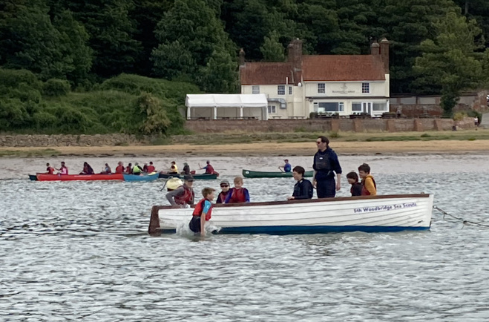
July ‘22 saw us attend and support the annual Wet Weekend Camp after two years off due to Covid-19. We took 11 Scouts across both troops as participants, a Young Leader, and a JO helper, who used their Power boat qualifications to help us with safety cover. We also provided our pulling boats and Oyster Catcher and lead Pulling for the event.

In August we will be attending the County Suffolk Punch Camp with Monday Troop, with around 32 youth members attending. In October we will be embarking on our 4th Norfolk Broads Adventure Cruise (and we can’t wait!).

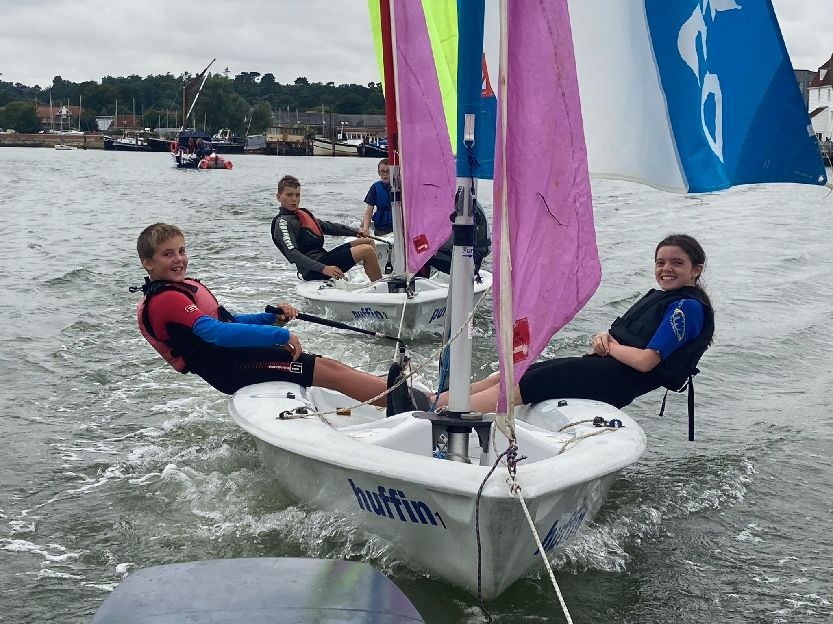
We have spent almost every week this term on the water, both at Friston and on the river. Earlier in the year, we covered a range of activities including First Aid, FASK, and worked on areas of our World Challenge. This included a visit to Ipswich Wheelchair Basketball club at Northgate Sports Centre and inviting Grandparents to the hut to play board games.

As always, we would like to thank all our leaders, parent helpers and Young leaders for their highly valued support and assistance throughout the year. We really could not do what we do without you all.

SCOUT REPORT(Monday section) Gareth Symonds Scout Leader
5th Woodbridge Sea Scouts (Perishers Troop) was launched at the beginning of this year. Named after the Royal Navy Submariners Command Course we have got off to a great start. We have 16 committed scouts and a team of seven leaders, many new to scouting and scout leadership. The scouts have enjoyed a range of scouting activities and are having lots of fun. Looking forward we aim to have all the scouts in uniform and invested by September. Setting up a new troop has had its challenges and would not have been possible without the support from Group Scout Leader, Assistant Group Scout Leader and the Friday Troop Leader. On reflection, if we were to do this again, seconding an experienced Scout leader for the first six months could be helpful. We aim to take more scouts next academic year and we are proud to be part of 5th Woodbridge.

EXPLORER SCOUT REPORT – Jane Stone, Explorer Scout Leader
This year it was great to finally get back to face to face scouting.
Summer camp was very different this year as the place we normally go to in Cornwall was closed and there was very little availability at any campsite. In the end we had a very relaxed camp at Thriftwood with lots of whittling round a fire. Menu was planned by the explorers and we had some excellent food and different to the usual camp bolognaise. A hammock city was built over the first few days with everyone sleeping out one night and 2 for the entire week. A trip to Lee Valley white water rafting was a highlight of the week.
After the summer break we started off the year with 3 back to back weekends of water activities culminating in a session with assessing instructors available.
4 permits to lead and 2 personal permits were issued which is a great performance considering how little time we have had on the water and a real testament to the time spent on the water in scouts.

Explorer Leaders also couldn’t wait to get more scouting in so organised another camp in October for Younger explorers and older scouts. Over 70 Youth attended and was well supported by leaders across the district.

We rounded off the year with a trip to Comic con in London, a chilly kayak to Ufford, some Chrsitmas crafts and a cooking competition among other things

The First half of the year has been a welcome return to more normal scouting after the last 2 years
Highlights were a cardboard sleep out for centrepoint a homeless youth charity, Axe throwing and of course the return of the annual Cub and Beaver Easter Egg hunt.

We took full advantage of the time at Friston and assisted the other sections with getting on the water.
Once again our Offshore powerboating was frustrated by the weather but we did manage to get out on the Orwell for some different experience. We all thoroughly enjoyed the 5th at 50 celebrations and have managed to spend a great amount of time on the water due in no small part to the huge investment in kit from the group which has made planning a session with the leader cover available so much easier.
Our thanks to the GSL and Exec for their tireless efforts.

NETWORK REPORT
The Network Section remains the quietest section. The Network is not a traditional activity section but was set up to keep contact with young members who have departed for university, during their term breaks the members are invited back to help with water and land activities for the younger sections. In time these members may become the Groups Leaders of the future.

GROUP POLICY AND OBJECTIVES

At the end of the period, cash reserves amounted to £11,634.12 after deduction for current liabilities due within the year. The Group’s policy on reserves is to hold an amount sufficient to cover the essential running costs for the next 6 months and to budget for longer term maintenance and capital replacement to ensure the long term viability of the Group.

The executive committee has started a fund to pay for refurbishment/ replacement of the headquarters building, £39,923.06 has been reserved this purpose.

The executive committee has also reserved £3481.40 given in grants for new boats and repairs to the boat shed for this purpose.

The objectives of the group are to follow the aims of the Scout Association to promote the development of young people in achieving their full physical, intellectual, social and spiritual potential. The Group is a trust established under the rules of the Scout Association, which are common to all Groups/Districts. Trustees are appointed in accordance with the Policy, Organization & Rules of The Scout Association.

The accounts, which cover a 12 month period, have been drawn up on the receipts and payments basis, which is consistent with the previous year.

Approved by the trustees on 7/7/22

Receipts & Payments Account Summary for the year ended 31st March 2022

This year Previous Year

Total receipts for the year (see page C7) 48963.94 41,791.55

Total payments for the year (see page C8) 52040.10 21,949.03
_____ ________
Net receipts (payments) for the year (3076.16) 19842.52

Cash, bank and similar funds brought forward 58114.88 38272.36

Cash, bank and similar funds carried forward £55038.72 £58114.88
(Net Monetary Assets, see page C9)

The above account and accompanying statement of assets and liabilities were approved by the Trustees

on 7/7/22 and signed on their behalf by

........Jonathan Douse......................Group Treasurer

Receipts for the year ended 31st March 2022

This Year Previous Year
£ £

MEMBERSHIP SUBSCRIPTIONS 13384.90 4021.42 District Fees refund nil 132
Less on line scout manager (164.37) (115)
Less Association fees paid (5518) (note) (8458) (note)
7702.53 (4419.58)

INVESTMENT INCOME RECEIVED

Bank Interest BPA a/c 3.2 7.20
3.20 7.20
DONATIONS/GRANTS
HMRC Gift Aid 707.31 3525.93
East Suffolk Council:
Kate Yule locality grant boat/building 1000 1500
Restart grant tent, tables and shelters 1080 1275.18
Restart grant kayaks nil 4893
Youth grant for Quest 1500
Town Council nil 614
Royal Navy for new boat 5000 5000
COVID Lockdown Grants 10667 20708
From donor for new boat 5700 1814.50
Mrs Rope paddle boards 600 nil
Ransomes for new HQ 1500 nil
Notcutts for new HQ 1500 nil
Amazon for Quest 1401.96 nil
Waldrignfield Boat yard for Rib 2500 nil
Parents for HQ 400 nil
Others 407.24 228.75
33963.51 41,782.78

ACTIVITIES 3988.20 nil

FUND RAISING 627.50 371.09
GRANT for Tea Pot project 200 3079.36

RENT 1898 492

SUNDRY RECEIPTS ` 111
Boat Insurance 470 476.20
Training nil nil
581 478.70

TOTAL RECEIPTS FOR THE YEAR £48963.94 £41,791.55
(note) association fees 2020 were billed on 31/3/20 and were paid in tax year 20-21 (£4180).
Payments for the year ending 31st March 2022

This Year Previous Year
£ £
PREMISES
Light/Heat/Water 722.18 957.67
Insurance 868.10 752.59
Repairs and Renewals 1802 1438.93
COVID PPE 34.29 814.35
Boat shed repairs 302.93 1362.13
3729.50 5325.67

BOATS
Insurance 2834.36(note) 3783.88 (note)
New Kayaks nil 5995.94
New paddle boards 2844.30 nil
New Dock 2500 nil
Oyster catcher 10,000 nil
New Rib 16570 nil
Repairs and Renewals 2973.86 1644.63
37722.52 11424.45

DONATIONS/GRANTS nil nil

ACTIVITIES
Activities 3707.43 318.65
Equipment (new tables and shelters) 2516.08 1172.18
6223.51 1490.83

FUND RAISING EXPENSES 573.97 231.99

ADMIN/ESTABLISHMENT EXPENSES 48.55 nil

TRUSTEES EXPENSES nil nil

OTHER EXPENSES
TEA POT project 200 2679.36
RN Inspection nil nil
Training 449 105
Personal Group insurance 42 42
691 2721.36

PURCHASE OF BADGES/BOOKS 560.06 542.24

SUNDRY PAYMENTS
Miscellaneous 95 18.24
Uniform/Life Jackets 2395.99 194.25
2490.99 212.49

TOTAL PAYMENTS FOR THE YEAR £52040.10 £21,949.03 Note boat insurance includes costs for 2021 and 2022 in last year

Statement of Assets & Liabilities at 31st March 2022

This Year Previous
Year
£ £

MONETARY ASSETS
Cash, bank and similar funds
Bank Current Account(s) R&P A/C 8217.56 24,791.08
‘Subs’ A/C 3416.70 8621.80
‘Fund Raising’ A/C 3481.40 6452.37
Bank Deposit Account(s) 39923.06 18249.63
Cash in Hand (Petty Cash A/C) nil nil
Net Monetary Assets (see page C4) 55038.72 58114.88

OTHER MONETARY ASSETS nil nil

INVESTMENT ASSETS nil nil

NON-MONETARY ASSETS for Charity’s own use

Land and buildings (insurance valuation) 341,393 323289
Boats and marine equipment (insurance valuation) 57146 39276
Scouting equipment (insurance valuation) 39539 29361
438,078 391926

LIABILITIES those due within one year

Cheques issued, not yet presented nil nil
Expenses incurred not yet invoiced nil nil
nil nil

LIABILITIES those payable after one year nil nil

CONTINGENT LIABILITIES AND FUTURE OBLIGATIONS: None None

Independent examiners report

I report to the trustees of 5th Woodbridge Sea Scouts (charity number 268265) on the accounts for the year ended 31st March 2021.

Responsibilities and basis of report
As the charity trustees of the Trust, you are responsible for the preparation of the accounts in accordance with the requirements of the Charities Act 2011 (“the Act”).

I report in respect of my examination of the Trust’s accounts carried out under section 145 of the 2011 Act and in carrying out my examination, I have followed the applicable Directions given by the Charity Commission under section 145(5)(b) of the Act.

Independent examiner’s statement
I have completed my examination. I confirm that no material matters have come to my attention in connection with the examination which gives me cause to believe that in, any material respect:
- accounting records were not kept in accordance with section 130 of the Act or
- the accounts do not accord with the accounting records

I have no concerns and have come across no other matters in connection with the examination to which attention should be drawn in order to enable a proper understanding of the accounts to be reached.

Signed: Date: 30/6/22

Name: Richard Short FCCA

Professional Qualifications: Chartered Certified Accountant

Address: 20 Hercules Road, Rendlesham, Suffolk IP12 2GP

Budget* for the 12month period to 31st March 2023
Essential Running Costs
£
ASSOCIATION FEES 6000

PREMISES
Light/Heat/Water 1000
Insurance 900
Repairs and Renewals (Note 1) 2000
3900

BOATS
Insurance 2800
Running costs, Repairs and Renewals (Note 2) 2200 5000

ADMIN/ESTABLISHMENT EXPENSES 80

TRUSTEES EXPENSES nil

OTHER EXPENSES
RN Inspection nil
Personal accident insurance 45
Training 400
445

PURCHASE OF CAPITAL EQUIPMENT
Tents and camping equipment 1500

PURCHASE OF BADGES/BOOKS 600

SUNDRY PAYMENTS
Miscellaneous nil

ACTIVITIES (note 3) 1000

TOTAL ESSENTIAL RUNNING COSTS FOR THE YEAR: £18525

Note 1- essential repairs and Health &Safety expenditure.
Note 2 – includes mooring fees, essential servicing and maintenance of existing boats and motors.
Note 3 Scouting activities should be self-financing but have run at a deficit in previous years. In 2018-19 activities ran a deficit of £1015. In 2017-18 activities ran a deficit of £926.73. 2019-20 deficit £589

ESTIMATED INCOME FOR YEAR

SUBSCRIPTONS 13500
Gift Aid 3700
17200

DONATIONS / GRANTS
Rent of hall/ parking 2000

UNIFORM/ T-SHIRTS 300

FUNDRAISING 1000

TOTAL ESTIMATED INCOME FOR THE YEAR (note 6): £20500

.
Appendix A
Accounts relating to Debenside Explorer Unit

Lloyds Bank
Sort code 309985
Account 5101676
Statement of Assets & Liabilities at 31st March 2022
This Year Previous Year
£ £
MONETARY ASSETS
Cash, bank and similar funds
Bank Current Account(s) R&P A/C 622.14 432.92
Cash in Hand (Petty Cash A/C) nil nil
Net Monetary Assets 622.14 432.92

OTHER MONETARY ASSETS nil nil

INVESTMENT ASSETS nil nil

NON-MONETARY ASSETS for Charity’s own use

Land and buildings (insurance valuation) nil nil
Boats and marine equipment (insurance valuation) nil nil
Scouting equipment (insurance valuation) nil nil
nil nil

LIABILITIES those due within one year

Cheques issued, not yet presented nil nil
Expenses incurred not yet invoiced nil nil
Nil nil

LIABILITIES those payable after one year nil nil

Fundraising nil 20.15
Receipts for activities 4472.17 70
Receipts for subs 45 95
Transfer to 5WSS for subs nil (95)
Payments for kit nil nil
Payments for activities (4327.95) (248.88)
Net receipts (payments) 189.22 (158.73)

Transactions relating to Debenside Explorer unit included in 5th Woodbridge accounts during year 31st March 2021:
Subscriptions collected from Explorers 2700 590
Association fees (1157) (1980)
Online scouts manager (43) (43)
Badges nil nil
Camp costs (171.52)
Use of hall and equipment 1328.48 nil
Balance nil (1433)
Note association fees billed on 31/3/20 were £880 and were paid in tax year 20-21

